**Experiment No.: 1**

**Aim**

**Create the following tables:**

Deposit

actno varchar2(5) primary key , first letter must start with ‘d’ cname varchar2(15) foreign key references customer

bname varchar2(20) foreign key references branch amount number(8,2) not null, cannot be 0

adate date

branh

Bname varchar2(20) primary key

City varchar2(30) not null , any one of nagpur, delhi, bangalore, bombay

Customer

cname varchar2(15) primary key city varchar2(20) not null ,

Borrow

loanno varchar2(8) primary key / first letter must start with ‘l’ cname varchar2(15) foreign key references customer

bname varchar2(20) foreign key references branch amount number(8,2) not null, cannot be 0

**CO1**

**Procedure**

1. Create a database

Syntax:

CREATE DATABASE employee_details;

Output:

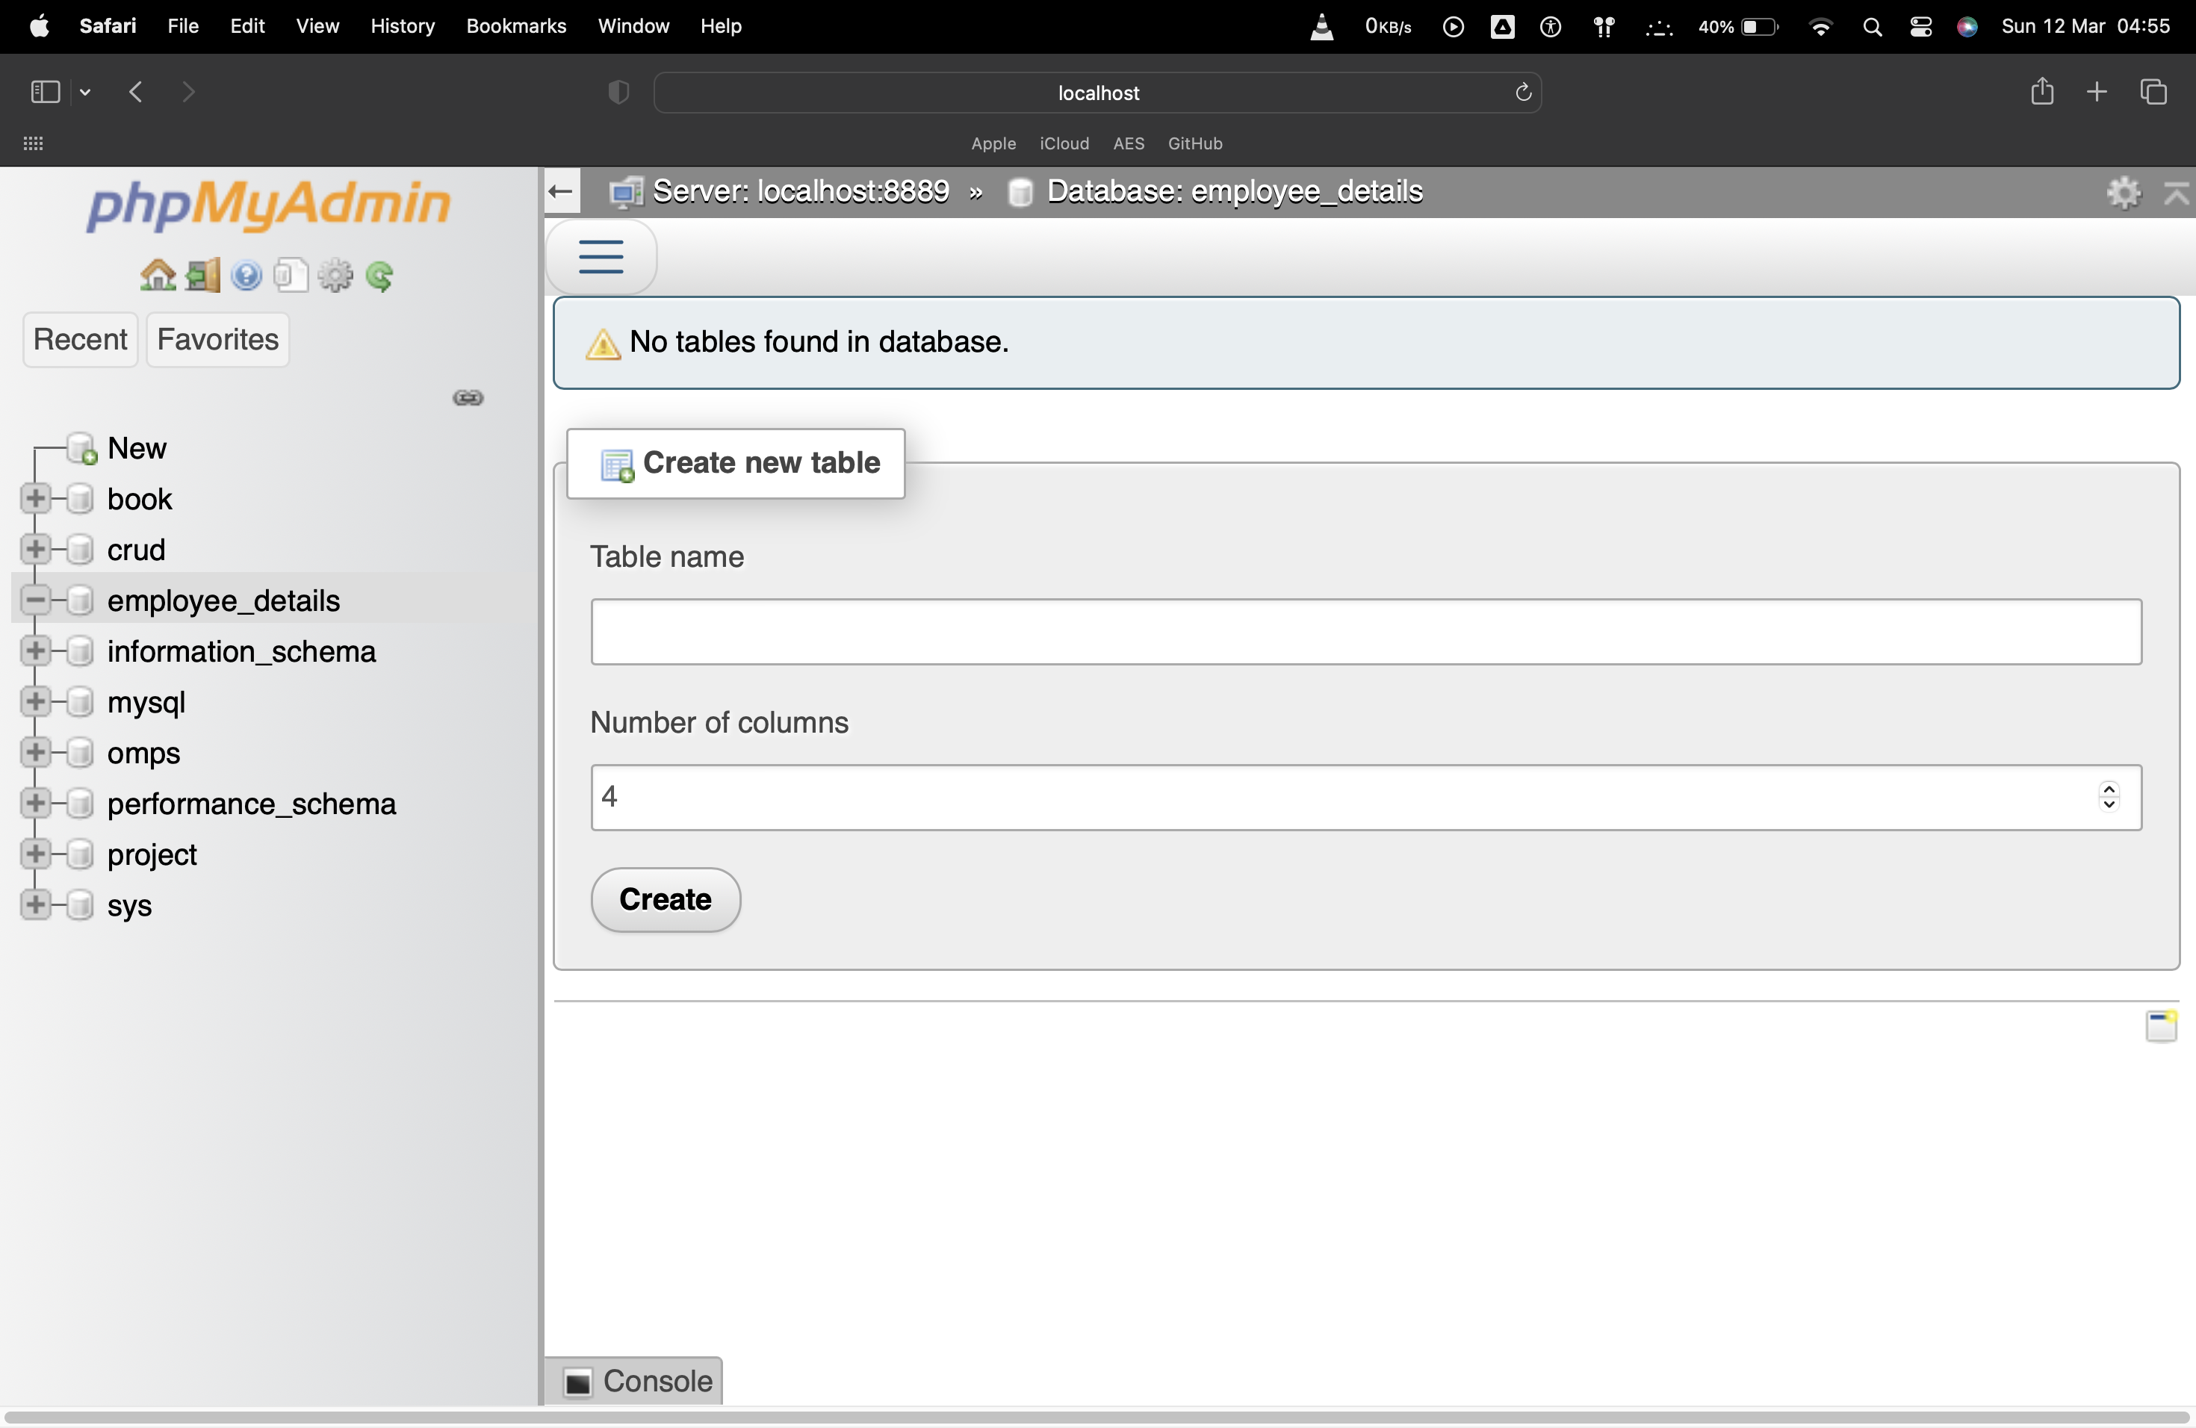

1. Create a table

Syntax:

CREATE TABLE department (dept_id int(11), dept_name varchar(111));

Output:

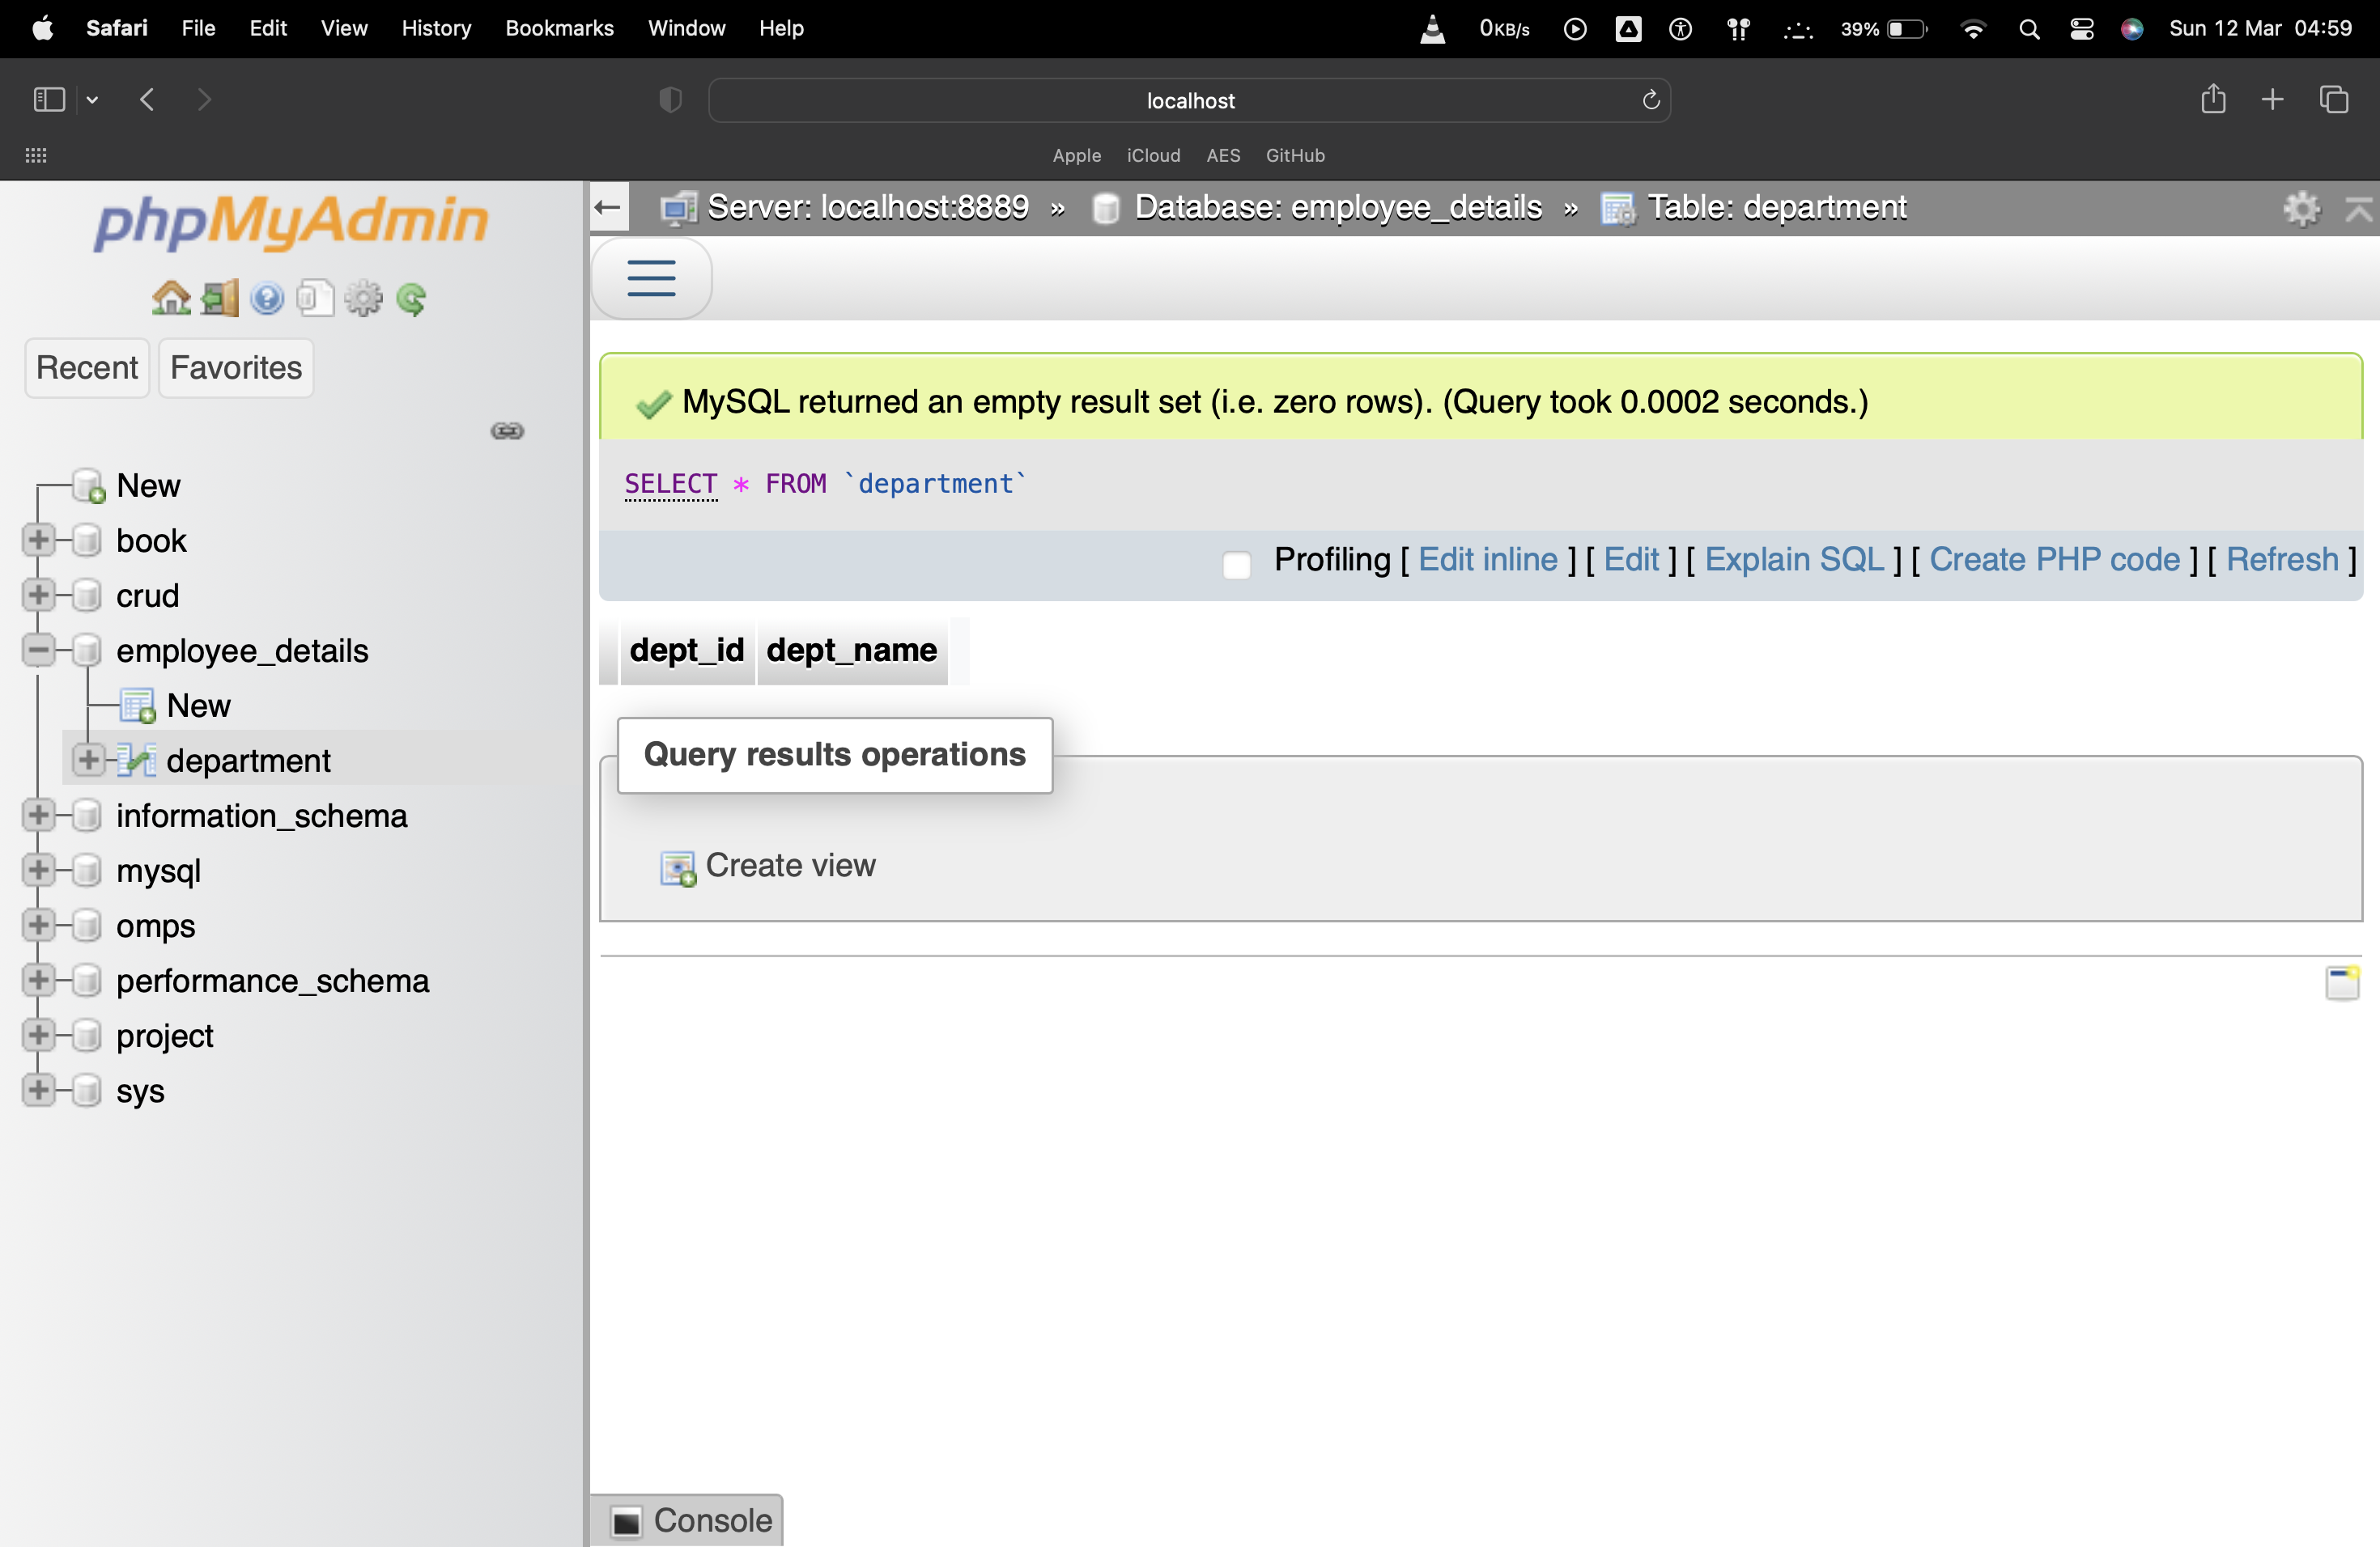

1. INSERT data into table

Syntax:

INSERT INTO department (dprt_id, dprt_name) VALUES (1, 'IT');

INSERT INTO department (dprt_id, dprt_name) VALUES (2, 'HR');

INSERT INTO department (dprt_id, dprt_name) VALUES (3, 'FINANCE');

INSERT INTO department (dprt_id, dprt_name) VALUES (4, 'ADMIN');

INSERT INTO department (dprt_id, dprt_name) VALUES (5, 'MCA');

Output:

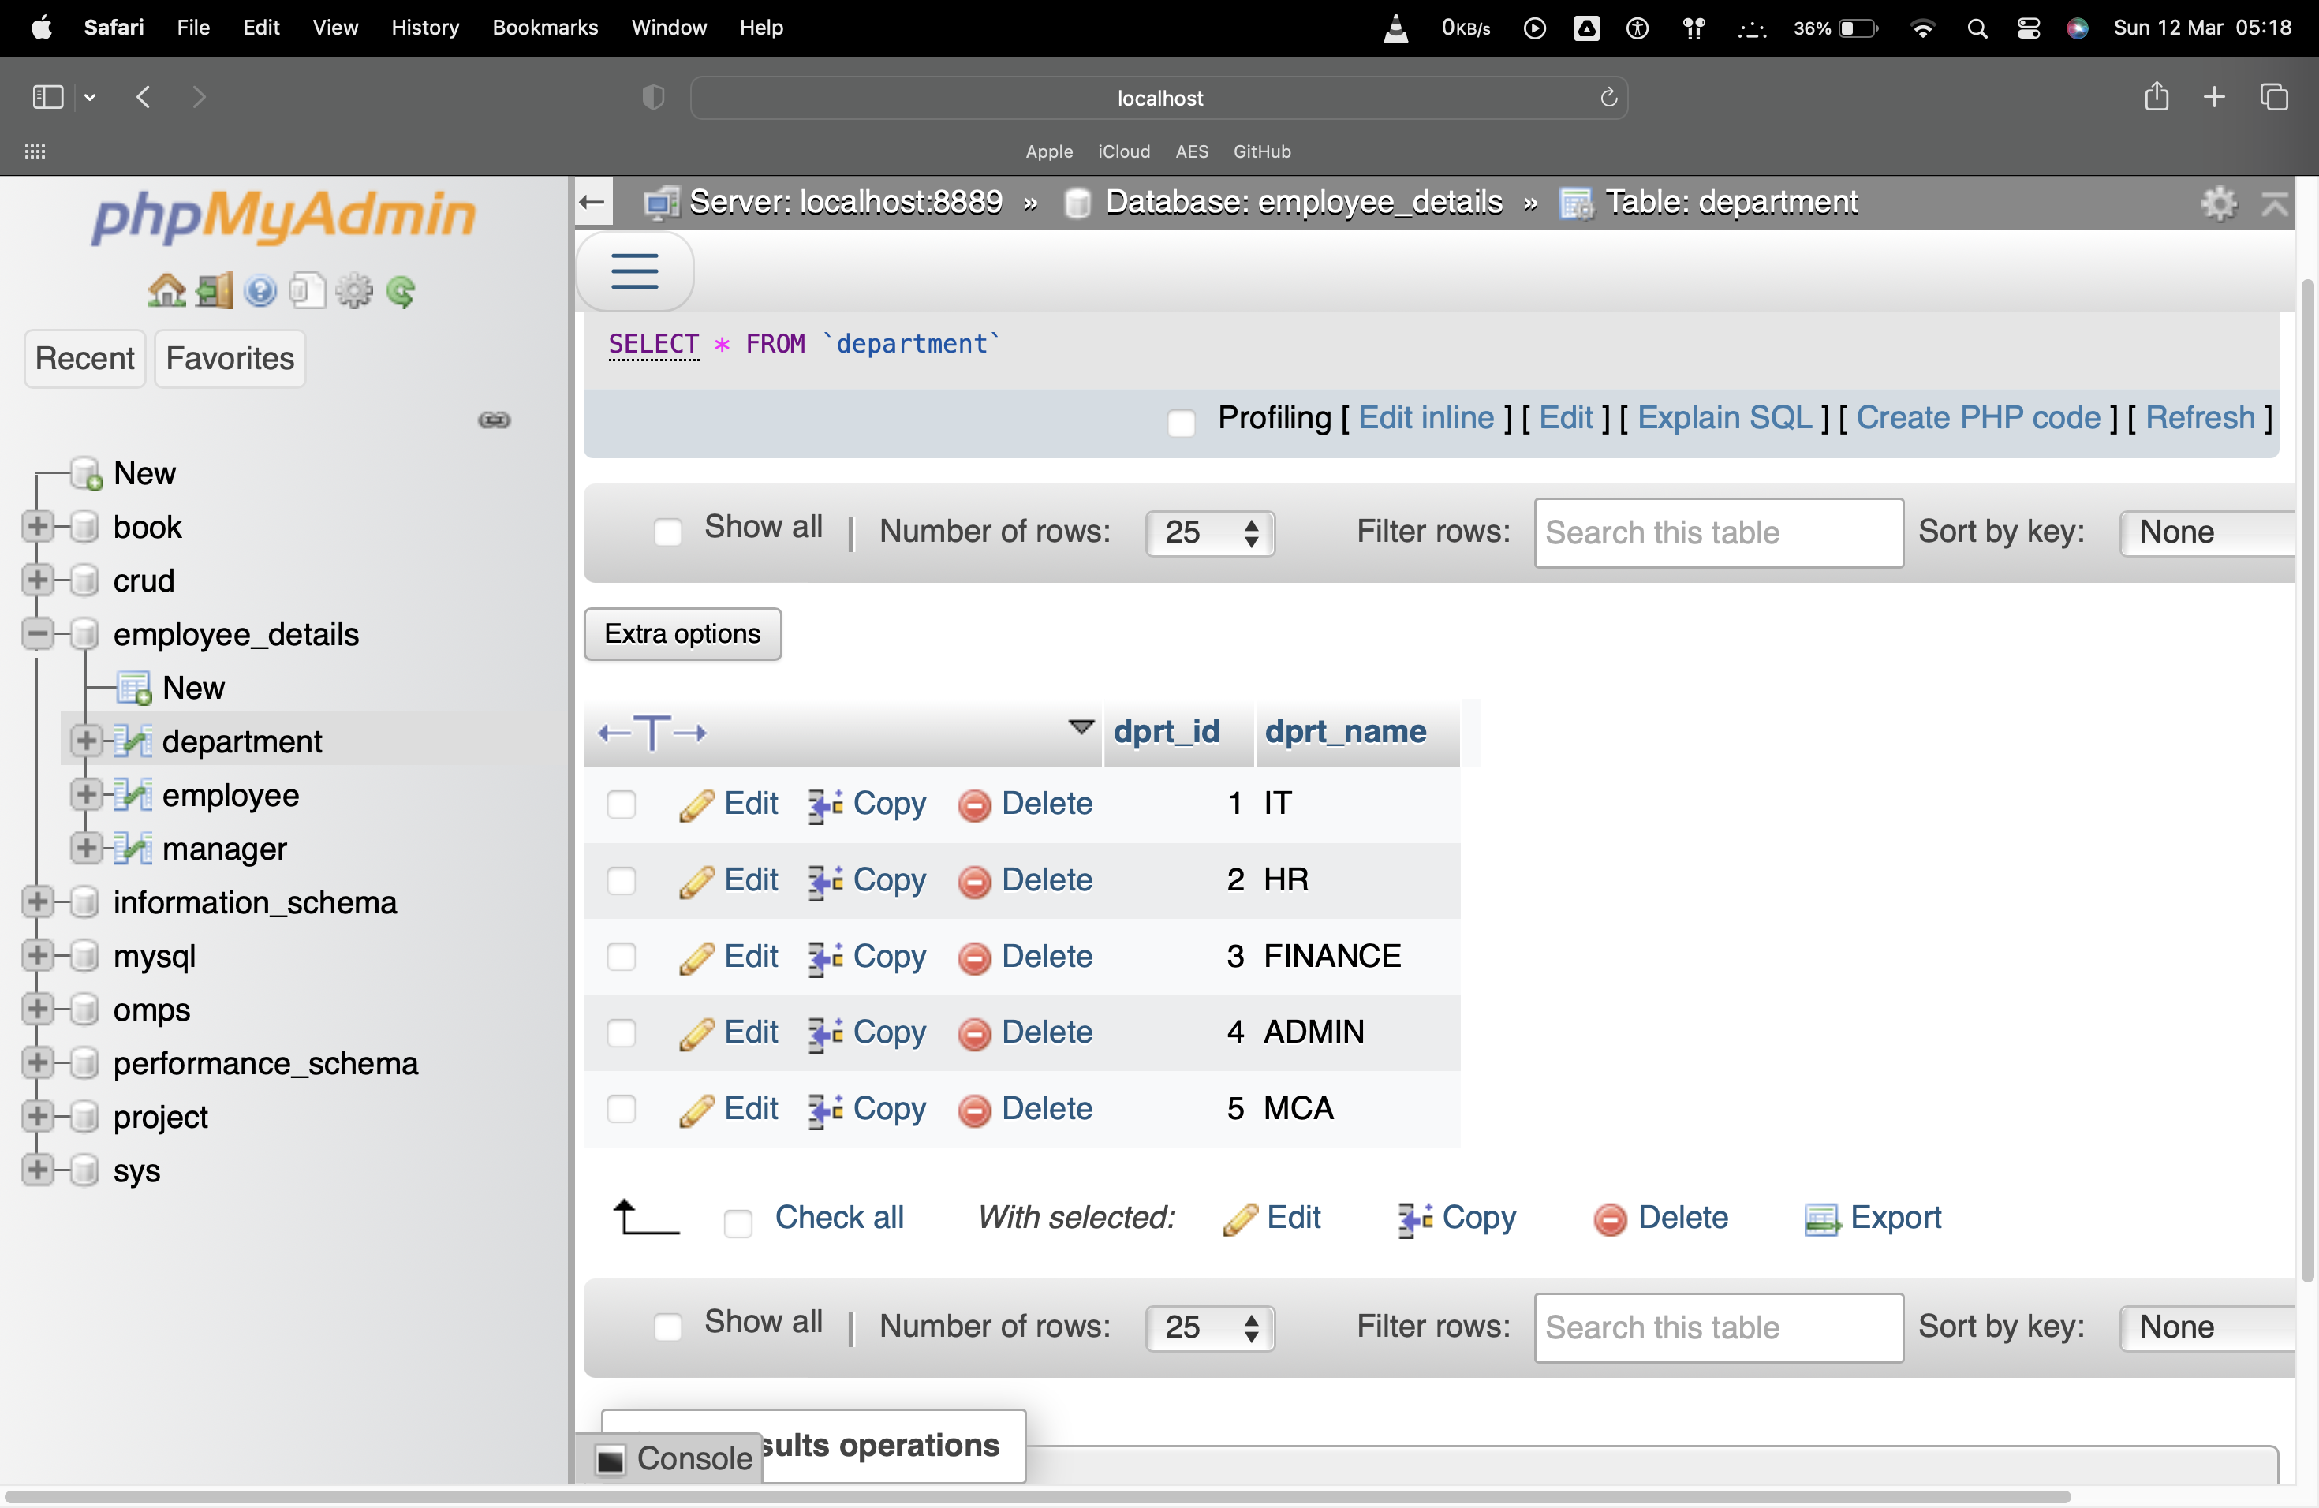

1. UPDATE data in a table

Syntax:

UPDATE department SET dprt_name = 'CSE' WHERE dprt_id = 3;

Output:

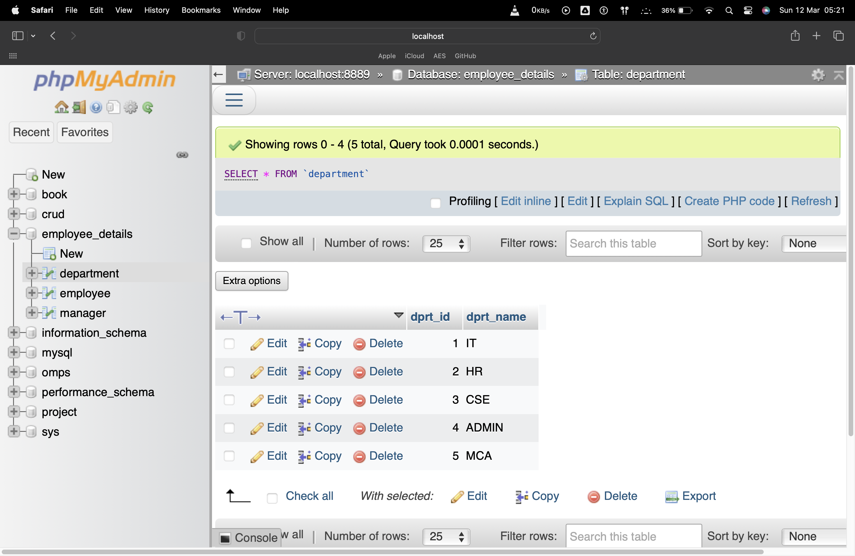

1. DELETE DATA from table

Syntax:

DELETE from department WHERE dprt_id = 5;

Output:

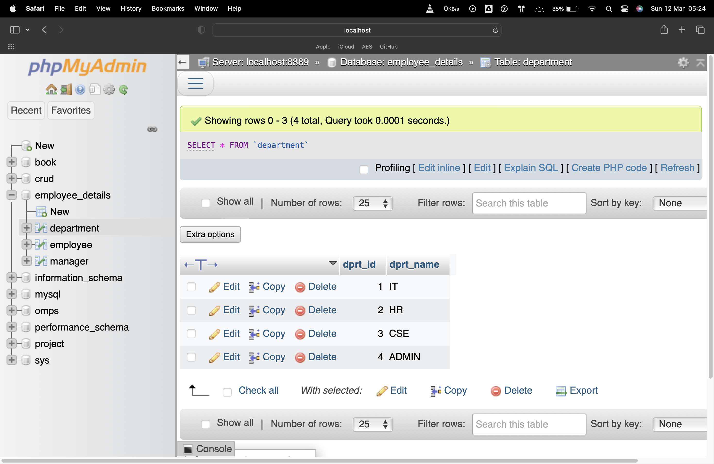

1. SELECT *

Syntax:

SELECT * FROM department;

Output:

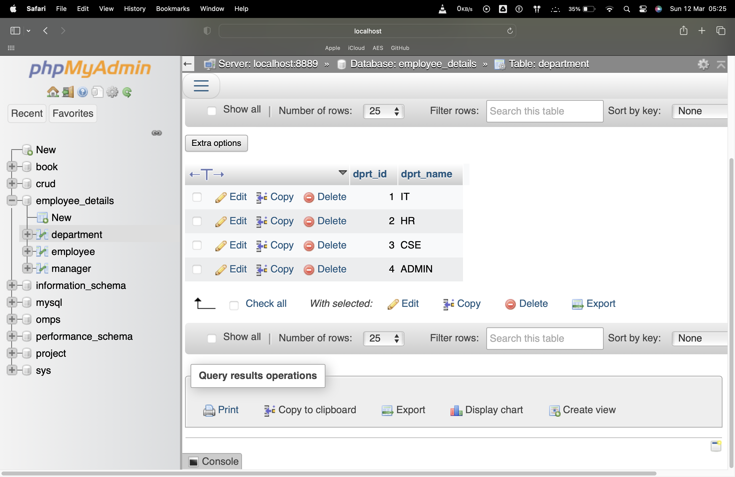

1. SELECT from table

Syntax:

SELECT * FROM department WHERE dprt_id = 1;

Output:

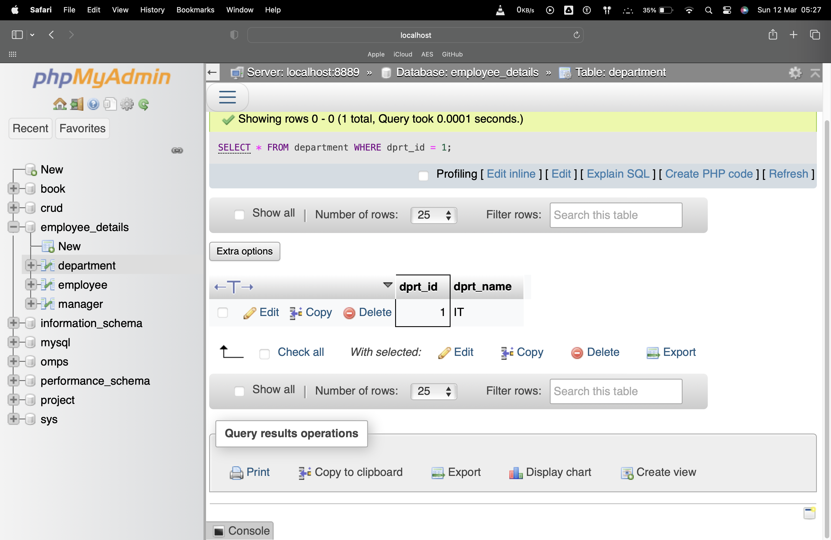

1. SELECT from table with dprt_id greater than 2

Syntax:

SELECT * FROM department WHERE dprt_id > 2;

Output:

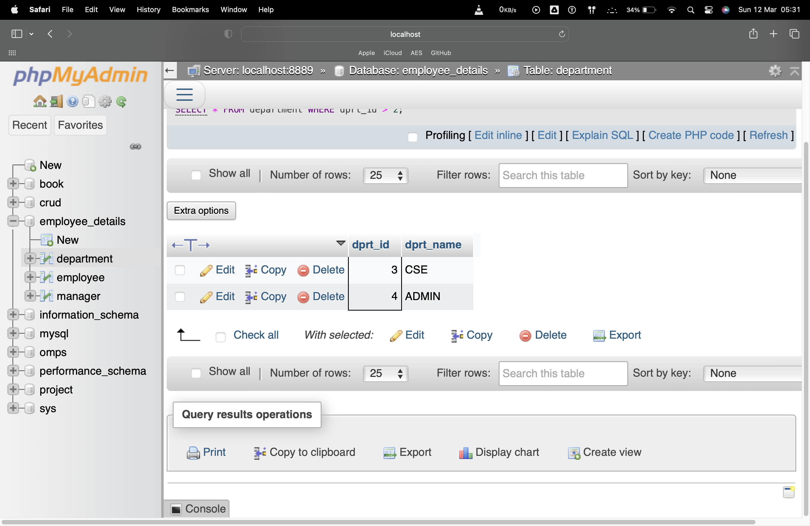

1. SELECT from table with dprt_id less than 2

Syntax:

SELECT * FROM department WHERE dprt_id < 2;

Output:

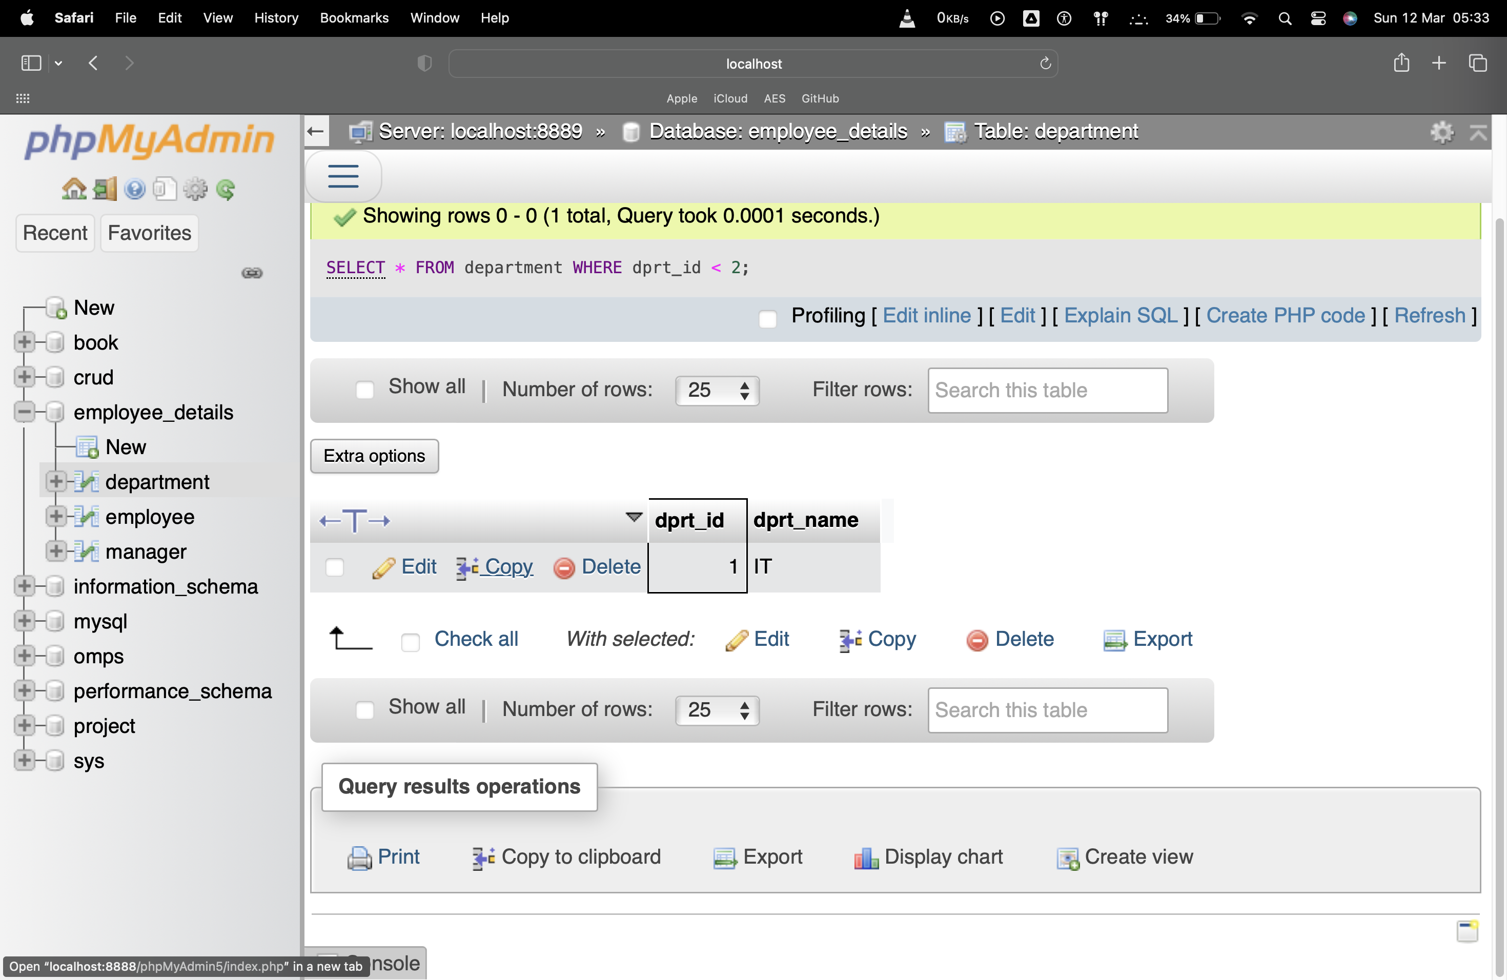

1. SELECT from table with dprt_id not equal to 2

Syntax:

SELECT * FROM department WHERE dprt_id != 2;

Output:

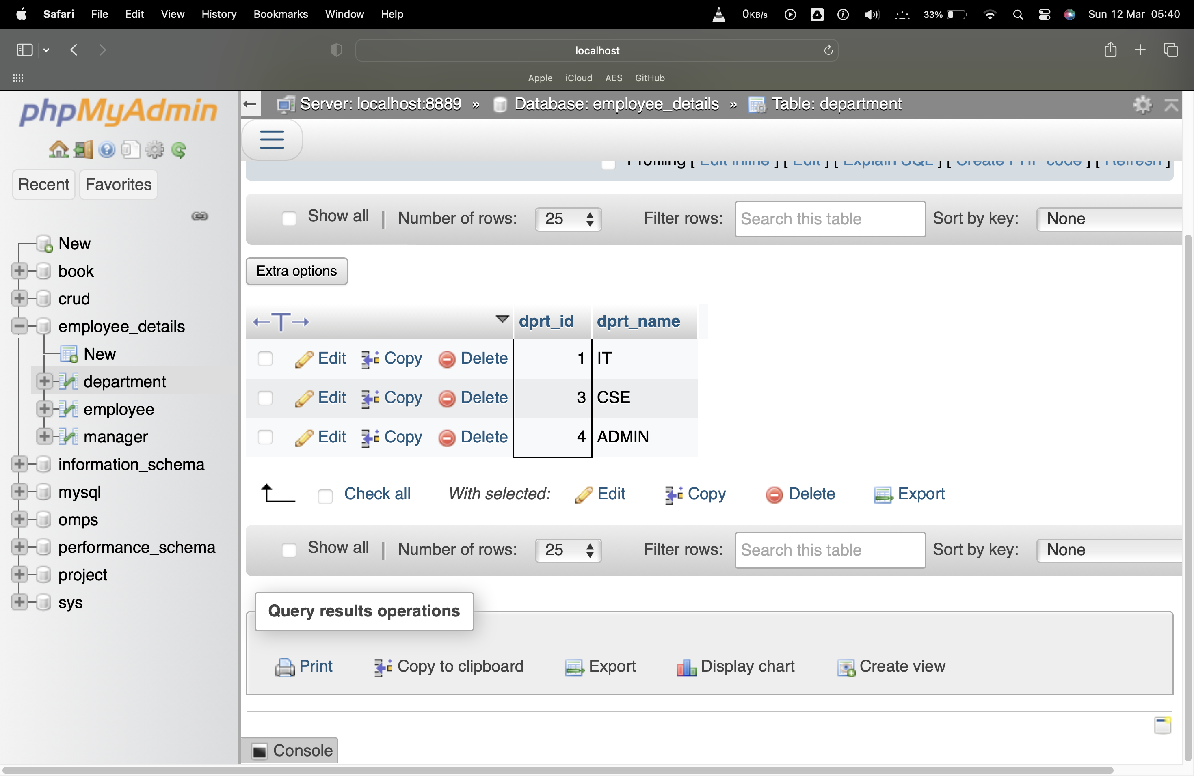

1. SELECT from table with OR

Syntax:

SELECT * FROM department WHERE dprt_id = 1 OR dprt_id = 3;

Output:

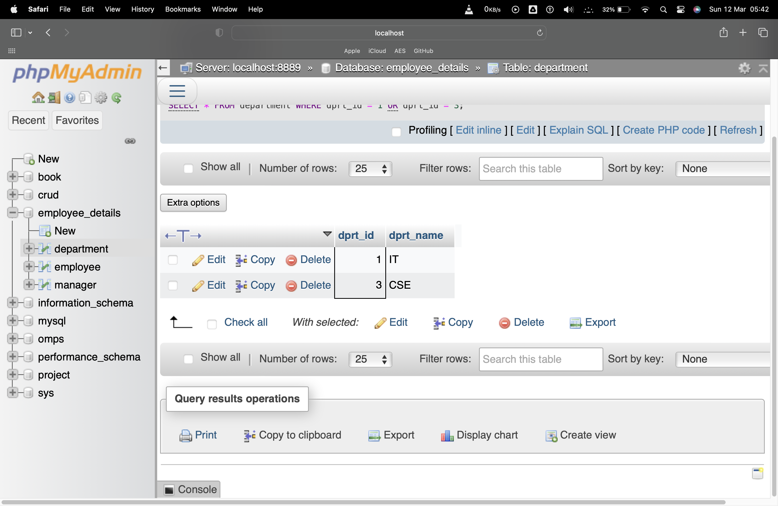

1. SELECT from table with AND

Syntax:

SELECT * FROM department WHERE dprt_id <= 3 AND dprt_id >= 1;

Output:

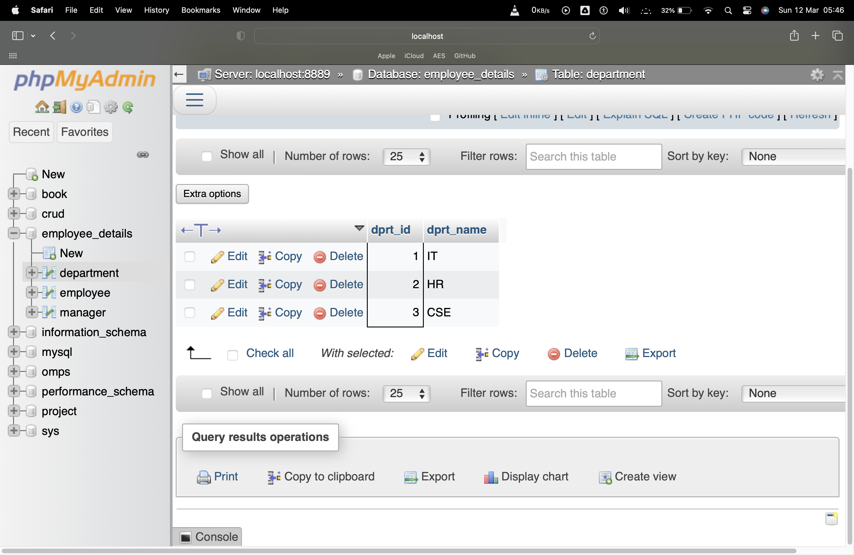

1. Fetch all the employee names and the department they belong to

Syntax:

SELECT employee.emp_name, department.dprt_name FROM employee JOIN department ON employee.emp_id = department.dprt_id;

Output:

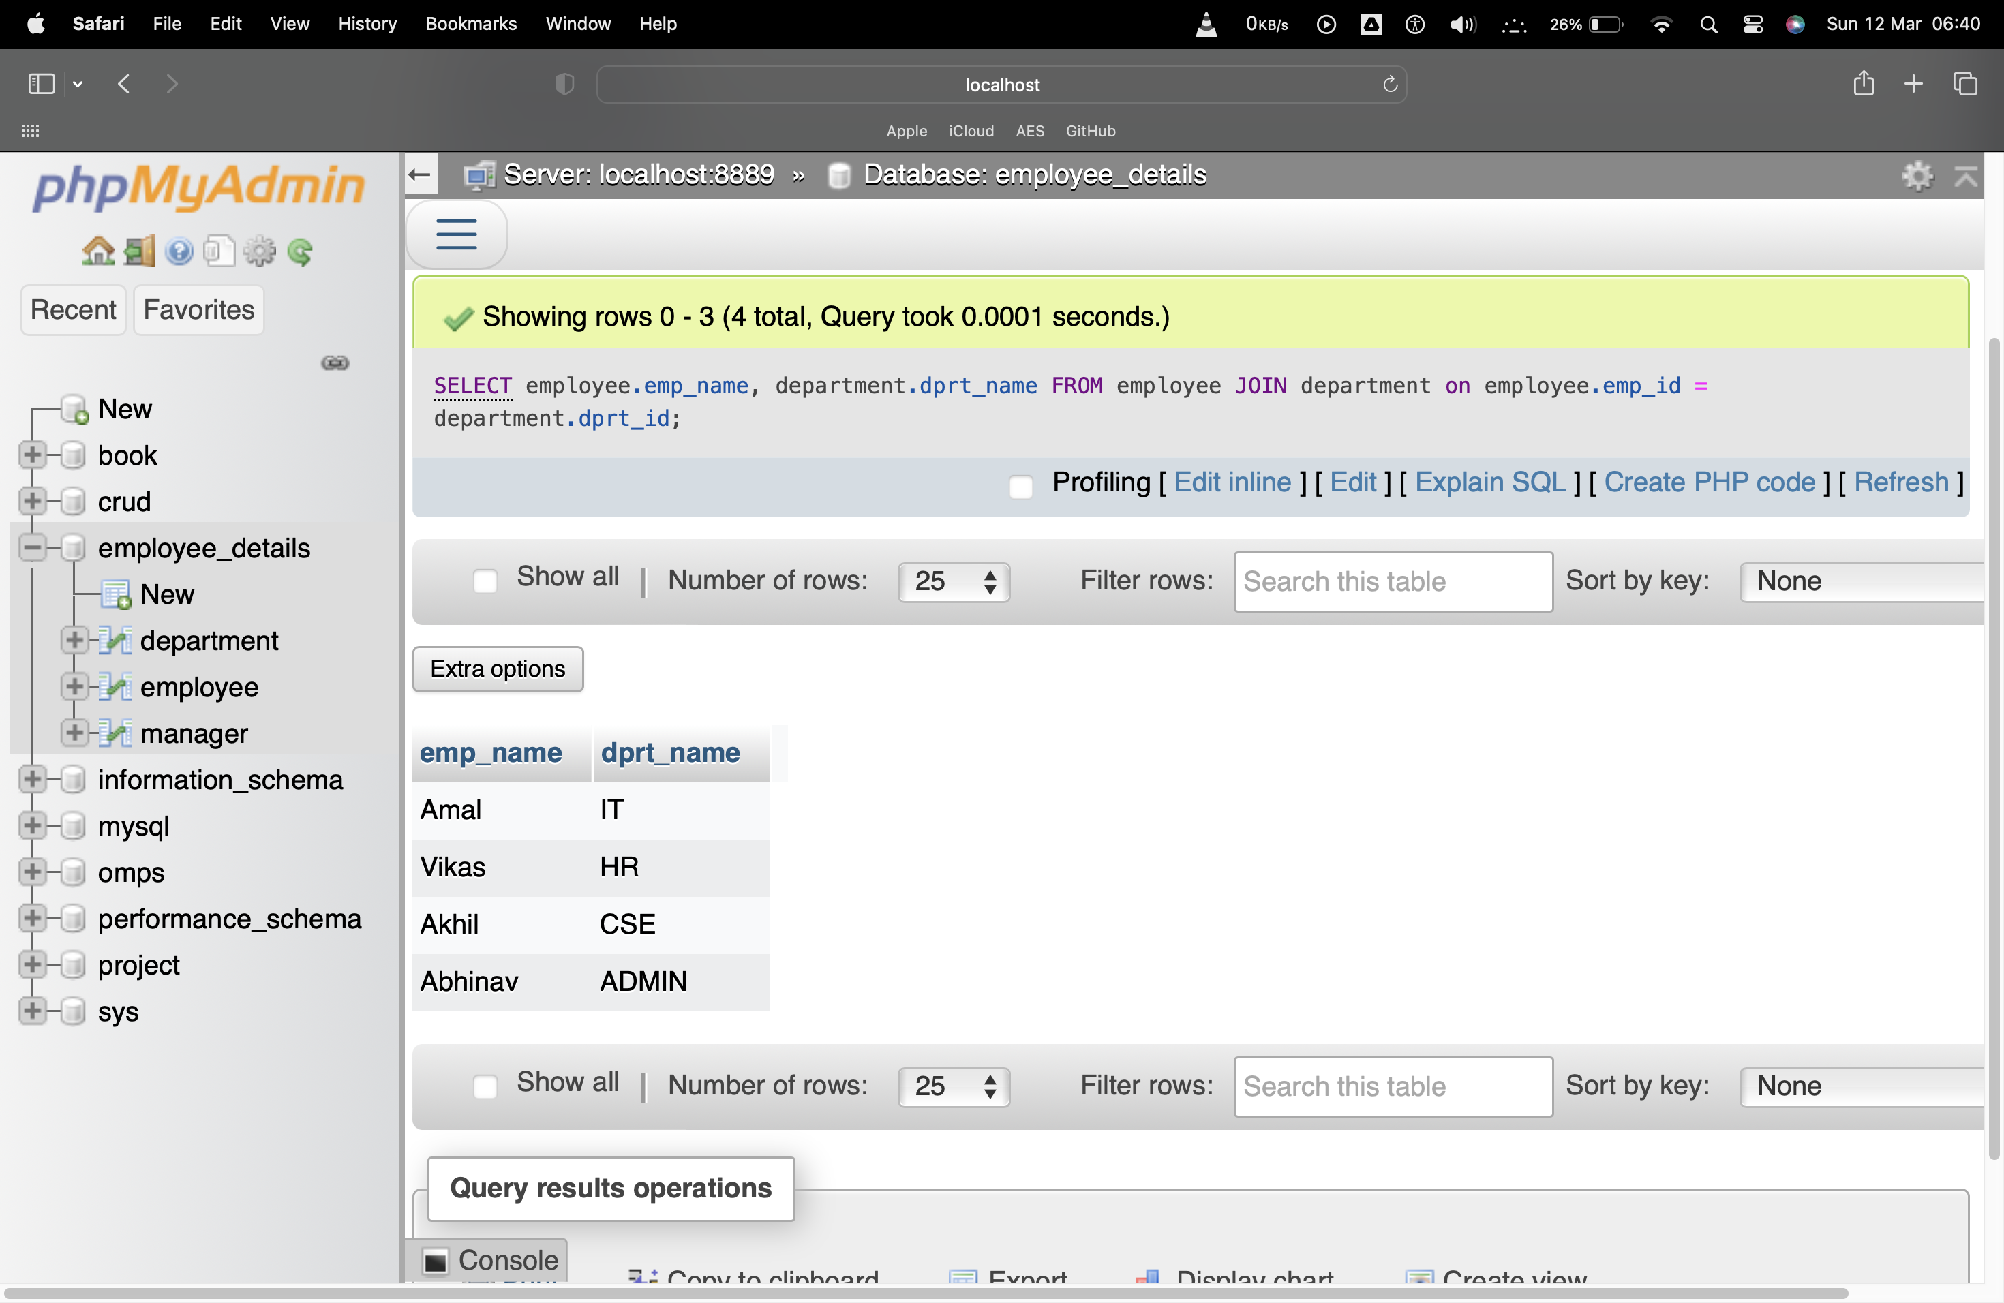

1. Fetch a employee name and the department they belong to

Syntax:

SELECT employee.emp_name, department.dprt_name FROM employee JOIN department ON employee.emp_id = department.dprt_id WHERE employee.emp_id = 1;

Output:

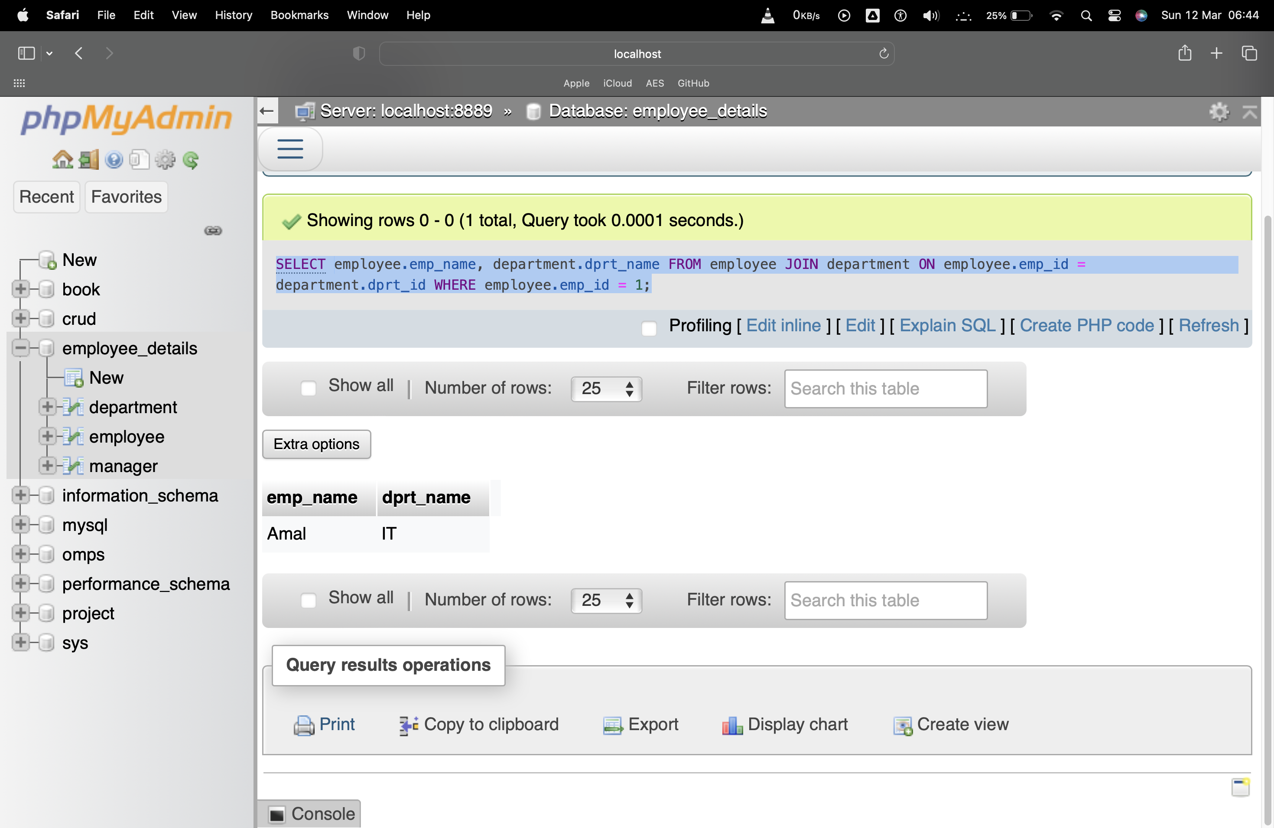

1. Fetch all the employee names, there manager names, there department and the projects they are working on

Syntax:

Output:

**Result**

The program was executed and the result was successfully obtained. Thus CO1 was obtained.